QA Automation interview Real Time Question

1] Can You Brief Me About Yourself?
Pls Answer Intro that we have shared with You in Session.
====================================================================
2] Tell me your Day to Day activities as QA?

First thing I do after login in my system. I check the active sprint in Jira for our project code. There I can see my assigned open tasks. After that I will check my mail if there is any important mail I need to take action on.
Thenwehaveourdailyscrummeetingwhereweusedtotellourpreviousdayactionswhatwedid,
what we are planning for today and if we have any blocker to discuss. Product owner and scrum master help us to resolve that blocker.
After that I need to take the pending task and do needed action whether creating test case, Execution, Defect retesting if any.
====================================================================
3] What is Data types?
Datatype are used to represent the type of data or information which we are going to used in JAVA program.

Types Of Data Type
1.Primitive Data Type:-
There are eight types of primitive data type. All the primitive data types are keywords, memory size of primitive data type are fixed. The first alphabet is always small (Lowercase).

2.Non-Primitive Data Types:-There are two types of non-primitive data types. Non-primitive data types are identifier. Memory sizes of non-primitive data types are not fixed. The first alphabet is always capital (Upper Case).

1.Primitive 2.Non-Primitive
byte – 1byte String(not fix size)
short – 2 byte Class(Not fix size)
int- 4 byte
long-8byte
float-4 byte
double-8byte
char-2byte
boolean-1bit

Q. What is JVM?
A. JVM stands for Java virtual machine. JVM is responsible for the interpretation of byte
code. In other words JVM is the component which understands the meaning of code.
JVM is responsible for the execution of class files.

Q. What is JIT?
A. JIT stands for Just In Time compiler. JIT is responsible for converting byte code into
Machine code in order to improve the performance of Java programs.

Q. What is JRE?
A. JRE stands for Java Runtime Environment. JRE provides an execution environment for
JVM in order to execute .class files. Without JRE JVM cannot execute the class file.

What is the use of + operator?
A. + Operator can be used to perform addition and concatenation. We can pass different
types of input for + operator. If the expression contains only numeric values, only
character values or else numeric and character values then addition will take place.
B. If the expression contains string value JVM will perform concatenation.
C. Concatenation is the process of joining two different inputs (concatenation is applicable
only for string input).

Identifiers:
1. Identifiers are the words created by developers.
2. Variable name, class name and method name will be considered as identifiers.
3. To create an identifier we have to follow some rules: 1. Every identifier must and
should contain alpha or alpha-numeric.
2. Identifier name should start with alphabet or else _.
For example: ABC123 is valid.
123abc is invalid.

Could you differentiate an Interface and an Abstract class?
An abstract class may have instance methods, which can implement a default behavior.
On the other hand, an interface can’t implement any default behavior.
However, it can declare different constants and instance methods.
While an interface has all the public members, an abstract class contains only class members like private, protected and so on.

What are the different ways you can use “Static”?
Static can be used in four ways: static variables, static methods, static classes and it can be used across a block of code in any class in order to indicate code that runs when a virtual machine starts and before the instances are created.
=====================================================================

Do you think all property of Immutable Object needs to be final?
Not compulsory as we can easily achieve the same by making member as nonfinal but private and not changing them except in the constructor. Also, avoid providing setter methods for them. If it is a mutable object, then prevent leaking any reference for that member.
=====================================================================
In Java, what is the default value of Float and Double?
Default value of Float is 0.0f while 0.0d for Double.

Access specifier/modifier

1. What are the access modifiers in java?
>> The access modifiers in Java specifies the accessibility or scope of a field, method, constructor, or class.
There are four types of Java access modifiers:
1. Private
2. Default
3. Protected
4. Public

=====================================================================
Q. What is the use of method in Java programming?
A. Method is a collection of executable Java statements. Java methods can be used to
develop business logic. The main advantage of using a method is reusability, it means
"Write once, execute multiple times".

Q. What is an object?
A. An entity having its own state and behavior is known as an object.
B. State represents characteristics of an object, whereas behavior represents functionality.
C. In terms of Java, an object is a copy of non-static data members and function members.
D. Non static data members represent the state of an object, whereas non static function
members represent behavior of an object.
E. Class is a container for object state and behavior, hence we have to create an object of
a class.
F. In Java an object is also known as an instance of class.

Q. Explain use of Java operators.
A. Operators are mainly used to perform operations on data.
B. Java operators play an important role in order to control program execution.
C. In Java, operators are classified into 6 categories:
1. Arithmetic 2. Assignment 3. Logical
4. Relational 5. Unary 6. Bit-wise.

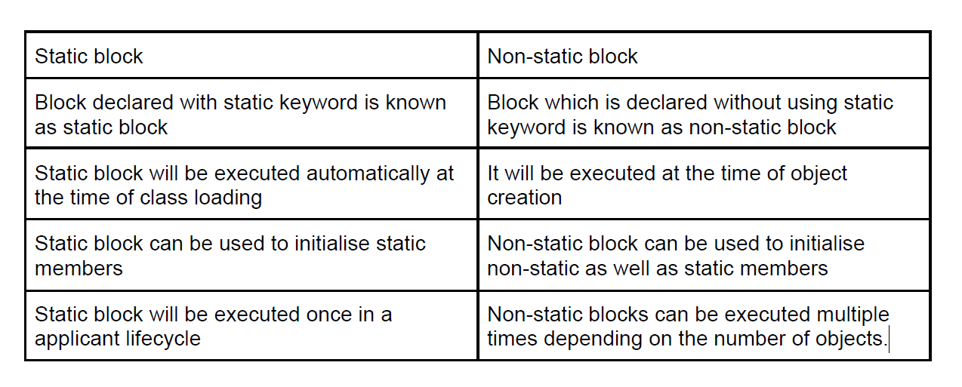

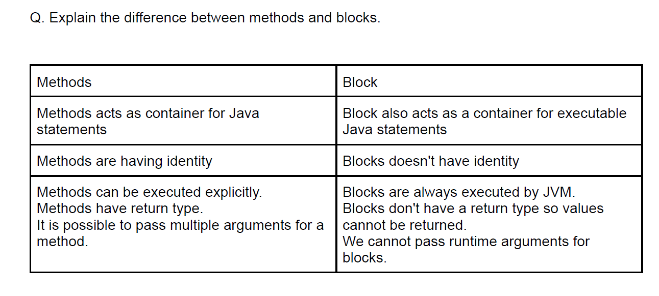
2. Can we have a private constructor in Java?
>>Yes, we can declare a constructor as private. If we declare a constructor as private we are not able to create an object of a class. We can use this private constructor in the Singleton Design Pattern.
(A singleton class is one which limits the number of objects creation to one.)
=====================================================================
3. Which access specifier can be used with a class?
>>Private, Default, Protected, Public. All access specifier used with a class.
=====================================================================

4. Can we declare a top-level class as private?
>>No, we cannot declare a top-level class as private or protected. It can be either public or default (no modifier). If it does not have a modifier, it is supposed to have a default access.
=====================================================================
5. Can we declare an abstract method as private?
>> No, An abstract class is permitted to have both concrete and abstract methods.
=====================================================================
6. Can a method or a class be final and abstract at the same time?
>>No, An abstract method can’t declare as final. you cannot override final methods in Java. But, in-case of abstract, you must override an abstract method to use it.
abstract and final both terms are opposite to each other. An abstract method says you must redefine it in a derived class. A final method says you can’t redefine this method in a derived class.
=====================================================================
7. Why are access modifiers used?
>> In Java, access modifiers are used to set the accessibility (visibility) of classes, interfaces, variables, methods, constructors, data members, and the setter methods

8. Which is the default access modifier?
>> Default access modifier means we do not explicitly declare an access modifier for a class, field, method, etc. A variable or method declared without any access control modifier is available to any other class in the same package.
=====================================================================
9. What is the default access modifier for Interface?
>> All abstract, default, and static methods in an interface are implicitly public. In addition, an interface can contain constant declarations. All constant values defined in an interface are implicitly public , static , and final. ( Methods -> public Variables -> public, static, final. )
=====================================================================
10. What is the role of private constructor in Java?
>> The private constructor is useful in case we want to restrict the object creation. For example, Singleton pattern can be implemented using a private constructor..
(A singleton class is one which limits the number of objects creation to one.)
=====================================================================
11. Which is the least restrictive access modifier in Java?
>> public.
The public is the most common and least restrictive access modifier in Java. You can apply public modifier into variables, methods and both top-level and inner classes in Java.
=====================================================================

12. Which is the most restrictive access modifier in Java?
>>Private access modifier is the most restrictive access level.
Methods, variables, and constructors that are declared private can only be accessed within the declared class itself.
=====================================================================
13. Which access modifier is also known as Universal access modifier?.
>>public access modifier is also known as universal access modifier.
(private access modifier is also known as native access modifier,
default access modifier is also known as package access modifier,
protected access modifier is also known as an inherited access modifier.
=====================================================================
Can we create an Immutable object, which contains a mutable object?
Yes, its possible to create an Immutable object which may contain a mutable object, you just need to be a little bit careful not to share the reference of the mutable component, instead, you should return a copy of it if you have to. Most common example is an Object which contain the
reference of java.util.Date object.
=====================================================================
How do you convert bytes to String? (answer)
You can convert bytes to the string using string constructor which acceptsbyte[], just make sure that right character encoding otherwise platform's default character encoding will be used which may or may not be same.
=====================================================================
Q. What are the users of this keyword?
1. This keywords always point to the current object.
2. It means address of an object and this keyword will be the same.
3. This keyword is mainly used to differentiate local and instance variables.
4. We can use this keyword only inside the non-static context, for example: constructor or
non-static method.

Q. What is an array?
A. ARRAY is a collection of multiple elements.
B. ARRAY can be used to store a group of the same type of elements.
C. It means we can store only homogeneous values inside the array variable.
D. In Java array classified into 2 types: Primitive and Non Primitive

What is string String:
String class is an internal class declared inside the java.lang package.
String class can be used to declare string values.
Every string value will be considered as a String object.
We can create String variables by using 2 ways:
1. Without using a new operator.
2. With using new operators.
All String values will be stored in the string pool area situated inside heap memory.
String pool area classified into 2 sections:
1. Constant Pool area
2. Non-Constant Pool area.
String Variables created without new operator will get stored inside the constant pool area.
String variable created using new operator will get stored inside the non-constant pool area.
● Constant pool area does not allow duplicate values.
● Non-constant pool allows duplicate values.

Q. Why String class immutable in nature?
1. Immutable means non-changeable.
2. Objects are classified into 2 categories i.e. mutable and immutable.
3. If an object is immutable then modifications are not possible inside the existing copy,
instead of that one separate copy will be generated for the modified string object.
4. String class is immutable in nature because after re-initialization or modification new
copy will be generated
5. After generating new copy old copy will be de-referred it means address variable will not
be available for old copy
6. String class is immutable; it does not mean that we cannot reinitialize the value.

Q. What is the use of while loop?
A. While loop can be used to perform multiple iterations, just like for loop.
B. While loop is executed until a certain condition is false.
C. It is also called an entry-control loop.
D. It is preferable to perform an unknown number of iterations.

Q. What is the use of a do-while loop?
1. It is similar to while loop which can be used to perform multiple iterations.
2. It is also known as exit-control loop, it means first java statements will be executed then
condition will be verified.
3. If we are using a do-while loop then at least one iteration will be performed every time.

Q. What is Constructor Calling?
1. The process of calling super class constructor using sub class constructor is known as
constructor calling.
2. If 2 classes are having IS-A relationship then constructor call is mandatory.
3. constructor calls can be done by using super() statements.
4. super() statement should be the first statement of constructor calling.it means multiple
super() statements are not allowed, because java does not support multiple inheritance.
5. Constructor call can be done implicitly as well as explicitly.

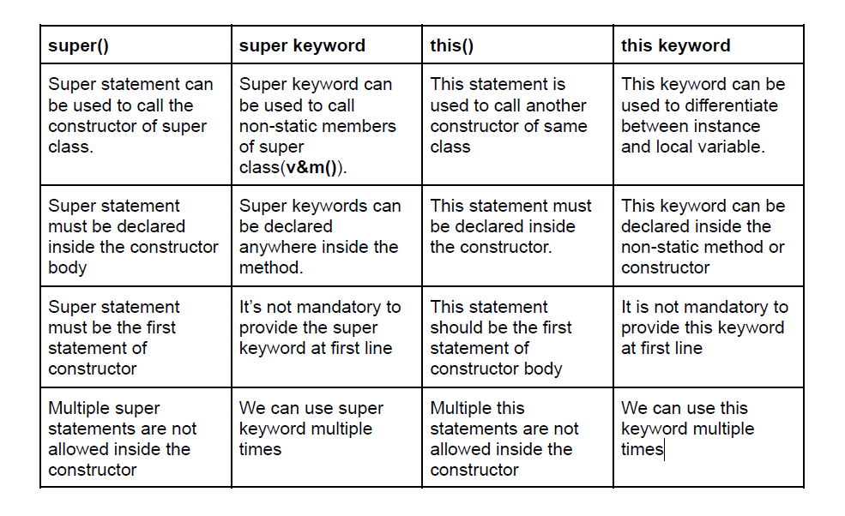

Q. What is method overloading?
1. The process of creating multiple methods with the same name but different arguments is
known as method overloading.
2. At the time of method overloading, parameters must be different either by parameter
length or parameter type.
3. Method Overloading can be used to achieve the same functionality, with different
parameters.
4. We can overload static as well as non-static methods.
5. It is possible to achieve compile-time polymorphism, by using method overloading.
6. Subclass can overload the method of superclass if two classes are having is-A
relationship.

Q. Is it possible to overload the main method?
1. Yes, it is possible.
2. If the class is having multiple main methods in such a case, JVM will execute the
standard Main Method.
3. The method which accepts the String[] type of arguments will be considered as the
Standard main method, remaining methods will be treated as external methods.
4. We have to call external main methods inside the standard main method for execution.

Q. What is method overriding?
1. The process of inheriting a method from subclass and changing its implementation in
subclass is known as method overriding.
2. In case of method overriding method signature should be the same, but method
implementation can be different.
3. It is used to achieve different functionalities with the same parameters.
4. It is possible only through IS-A relationship.
5. By using method overriding we can achieve run-time polymorphism.

Q. Which methods cannot be overridden?
1. We cannot override 3 types of methods:
● Static: they are the class members and they will be having a single copy inside
the JVM Memory hence it is not possible to override static methods.
● Private: They are not accessible outside the class so it is not possible to
override private methods.
● Final: If the method is final, then it is not possible to change the definition of the
respective method, hence we cannot override the final method.

Q. Explain the use of toString method.
1. toString method is declared inside the object class.
2. This method can be used to represent an object as a string value.
3. For the string representation of an object we have to override the toString
method inside the respective class.
4. toString method always returns String type of value.
5. Whenever we are printing a reference variable internally the toString method will
be executed and by default it will return the address of an object.

Q. What is the hashCode method?
1. Hashcode method is declared inside the object class.
2. Hashcode method can be used to identify a specific object.
3. Every object will be having a specific hashcode value which is present in integer format.
4. Hashcode value will be generated by JVM immediately after object creation.

Q. What is equals method?
1. Equals method is also declared inside the object class.
2. This method can be used for the comparison of 2 objects.
3. At the time of comparison the hashcode of an object plays an important role.
4. If 2 objects

Q. What is the getClass method?
1. It is declared inside the object class.
2. This method always returns a full-qualified class_nameof an object.
3. We can call this method by using the reference of a specific object.
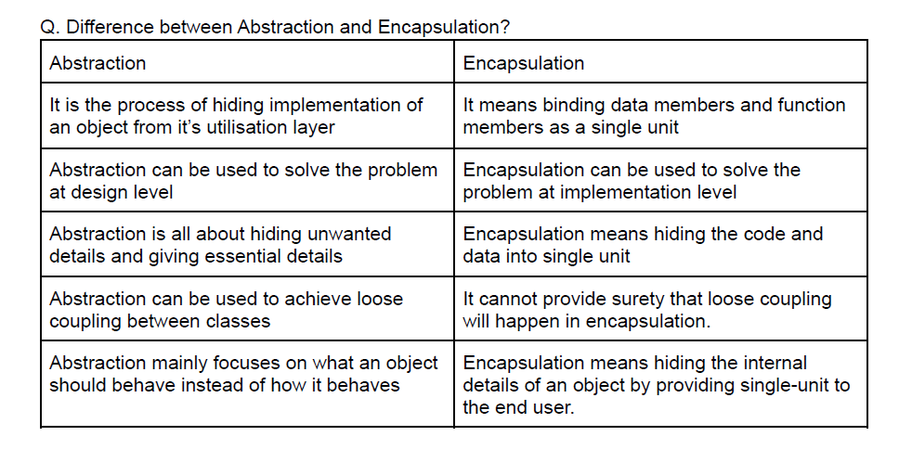
Can we cast an int value into byte variable? what will happen if the value of int is larger than byte?
Yes, we can cast but int is 32 bit long in java while byte is 8 bit long in java so when you cast an int to byte
higher 24 bits are lost and a byte can only hold a value from ­128 to 128.
=====================================================================
Do you work in cucumber, can you tell me what all files required in cucumber?
In cucumber we have Feature file, Step Definition file and Test Runner file.
In feature file we used to write scenario in gherkin language which is most like in plain English language. Here we use some of the keywords like feature, scenario, scenario outline, given, when, then, and, example, background keywords for writing our test scenarios steps.
In Step Definition file we write mapping code for all the scenario of feature file.
In test Runner file we provide the address of the feature file, step definition file, and all-important Tags, Plugin, Listeners in that.

What is the difference between scenario & scenario outline?

When we have single scenario and we need to run it one time at that place we use Scenario.
If you want some parametrization or Data Driven testing at that time, we can use scenario outline where we have to use Example keyword like if we are running this scenario for 3 different data set like username & pass. so, it will run 3 times

Which class contains clone method? Cloneable or Object? (answer)
java.lang.Cloneable is marker interface and doesn't contain any method clone method is defined in the
object class. It is also knowing that clone is a native method means it's implemented in C or C++ or any other native language.
=====================================================================

Can I store a double value in a long variable without casting? (answer)
No, you cannot store a double value into a long variable without casting because the range of double is more that long and you we need to type cast. It's not dificult to answer this question but many develoepr get it
wrong due to confusion on which one is bigger between double and long in Java.

=====================================================================

Why main method is static? Can we execute a program without main() method? If yes, how?
Java program's main method has to be declared static because keyword static allows main to be called without creating an object of the class in which the main method is defined. If we omit static keyword before main Java program will successfully compile but it won't execute. The answer to this question depends on the version of java you are using. Prior to JDK 7, the main method was not mandatory in a java program.
You could write your full code under static block and it ran normally.
The static block is first executed as soon as the class is loaded before the main(); the method is invoked and therefore before the main() is called. main is usually declared as static meth…

explain the various access modifiers used in Java.
Default – No keyword required
Private
Protected
Public
access-modifiers-in-java

1.Default:
When no access modifier is specified for a class , method or data member – It is said to be having the default access modifier by default.
The data members, class or methods which are not declared using any access modifiers i.e. having default access modifier are accessible only within the same package.

2.Private:
The private access modifier is specified using the keyword private.
• The methods or data members declared as private are accessible only within the class in which they are declared.
• Any other class of same package will not be able to access these members.
• Top level Classes or interface cannot be declared as private because
• private means “only visible within the enclosing class”.
• protected means “only visible within the enclosing class and any subclasses”
• Hence these modifiers in terms of application to classes, they apply only to nested classes and not on top level classes

3.protected:
The protected access modifier is specified using the keyword protected.
The methods or data members declared as protected are accessible within same package or sub classes in different package.

4.public:
The public access modifier is specified using the keyword public.
• The public access modifier has the widest scope among all other access modifiers.
• Classes, methods or data members which are declared as public are accessible from everywhere in the program. There is no restriction on the scope of a public data members.

Why Is String Immutable in Java?
An immutable object is an object whose internal state remains constant after it has been entirely created. This means that once the object has been assigned to a variable, we can neither update the reference nor mutate the internal state by any means.

The key benefits of keeping this class as immutable are caching, security, synchronization, and performance.
=====================================================================

What are the different class loaders used by JVM??
The Java ClassLoader is a part of the Java Runtime Environment that dynamically loads Java classes into the Java Virtual Machine. The Java run time system does not need to know about files and file systems because of classloaders.
Java classes aren’t loaded into memory all at once, but when required by an application. At this point, the Java ClassLoader is called by the JRE and these ClassLoaders load classes into memory dynamically.
=====================================================================
Types of ClassLoaders in Java??
Not all classes are loaded by a single ClassLoader. Depending on the type of class and the path of class, the ClassLoader that loads that particular class is decided. To know the ClassLoader that loads a class the getClassLoader() method is used. All classes are loaded based on their names and if any of these classes are not found then it returns a NoClassDefFoundError or ClassNotFoundException.

A Java Classloader is of three types:
• BootStrapClassLoader:
A Bootstrap Classloader is a Machine code which kickstarts the operation when the JVM calls it. It is not a java class. Its job is to load the first pure Java ClassLoader. Bootstrap ClassLoader loads classes from the location rt.jar. Bootstrap ClassLoader doesn’t have any parent ClassLoaders. It is also called as the PrimodialClassLoader.

• Extension ClassLoader:
The Extension ClassLoader is a child of Bootstrap ClassLoader and loads the extensions of core java classes from the respective JDK Extension library. It loads files from jre/lib/ext directory or any other directory pointed by the system property java.ext.dirs.
• System ClassLoader:
An Application ClassLoader is also known as a System ClassLoader. It loads the Application type classes found in the environment variable CLASSPATH, -classpath or -cp command line option. The Application ClassLoader is a child class of Extension ClassLoader.

=====================================================================

What is a join?

This is a keyword used to query data from more tables based on the relationship between the fields of the tables. Keys play a major role when JOINs are used.
What are the types of join and explain each?
There are various types of join which can be used to retrieve data and it depends on the relationship between tables.

Inner join.
Inner join return rows when there is at least one match of rows between the tables.

Right Join.
Right join return rows which are common between the tables and all rows of Right hand side table. Simply, it returns all the rows from the right hand side table even though there are no matches in the left hand side table.

Left Join.
Left join return rows which are common between the tables and all rows of Left hand side table. Simply, it returns all the rows from Left hand side table even though there are no matches in the Right hand side table.

Full Join.
Full join return rows when there are matching rows in any one of the tables. This means, it returns all the rows from the left hand side table and all the rows from the right hand side table.

What is a query?
A DB query is a code written in order to get the information back from the database. Query can be designed in such a way that it matched with our expectation of the result set. Simply,
a question to the Database.

How many types of memory areas are allocated by JVM?
JVM (Java Virtual Machine) is an abstract machine, In other words, it is a program/software which takes Java bytecode and converts the byte code (line by line) into machine understandable code.

JVM (Java Virtual Machine) acts as a run-time engine to run Java applications. JVM is the one that actually calls the main method present in Java code. JVM is a part of the JRE (Java Runtime Environment).

JVM perform some particular types of operations:
• Loading of code
• Verification of code
• Executing the code
• It provide run-time environment to the users
=====================================================================
Types of Memory areas allocated by the JVM??
All these functions take different forms of the memory structure. The memory in the JVM divided into 5 different parts:
Class (Method) Area
Heap
Stack
Program Counter Register
Native Method Stack
Let’s see about them in brief:

• Class Loader:
It is a subsystem of JVM which is used to load class files. It is mainly responsible for three activities.
• Loading, Linking, Initialization

• Class (Method) Area:
It stores class level data of every class such as the runtime constant pool, field and method data, the code for methods.

• Heap:
It is used to allocate memory to objects at run time

• Stack:
Each thread has a private JVM stack, created at the same time as thread. It is used to store data and partial results which will be needed while returning value for method and performing dynamic linking.
Java Stack stores frames and a new frame is created each time at every invocation of the method.
A frame is destroyed when its method invocation completes

Polymorphism

1. What is polymorphism in java?

>>Polymorphism : we can perform a single action in different ways. (One object showing
different behavior at different stages of life cycle.)
=====================================================================
2. Give real-life examples of polymorphism?

>> A person at the same time can have different characteristic. Like a man at the same
time is a father, a husband, an employee.
=====================================================================
3. How many types are of polymorphism in java?

>> 1. Compile time polymorphism (static binding)
2. Runtime polymorphism (dynamic binding).
=====================================================================
4. What are compile-time and run-time polymorphism?

>>1. Compile time polymorphism:-
In compile time polymorphism method declaration is going to get binded to it’s definition at compile time, based on argument is known as compile time polymorphism.
2. Runtime polymorphism:-
In run time polymorphism method declaration is going to get binded to it’s definition at run time, based on object creation is known as run time polymorphism.
=====================================================================
5. What is method overloading?

>> Declaring multiple methods with same name but with different argument in a same
class is called method overloading.
=====================================================================
6. What is method overriding?

>> when two methods have the same method name and parameters. One of
the methods is in the parent class, and the other is in the child class is called
method overriding.
=====================================================================
7. How to achieve Compile-time polymorphism?

>> Compile-time polymorphism is achieved through method overloading.
=====================================================================
8. How to achieve Runtime-time polymorphism?

>> Run-time polymorphism is achieved through method overriding.

=====================================================================
9. Can we achieve method overloading by changing the return type?

>> No, We cannot achieve method overloading through return type in java.

10. Difference between method overloading and overriding?

>>Overloading | Overriding
Method overloading is a compile time polymorphism. | Method overriding is a run time polymorphism.
It help to rise the readability of the program. | Used to provide specific implementation of the method that is already provided by its parent class or super class
It is perform within the class | It is performed in two classes with inheritance relationship.
In this, methods must have same name and different parameter. | In this, methods must have same name and same parameter.
return type can or can not be same, but we must have to change the parameter. | return type must be same or co-variant.
Example of Compile-time polymorphism. | Example of run-time polymorphism.

INTERFACE

1. Can we re-assign a value to a field of interfaces?

>>No, we can’t change the value of an interface field because interface
fields are final and static by default.
=====================================================================
2. Can we declare an Interface with “abstract” keyword?

>> There can be only abstract methods in the Java interface, not method body.
Interfaces can have abstract methods and variables. SoNo need to use it explicitly.
=====================================================================

3. For every Interface in java, .class file will be generated after compilation. True or false?

>>True. For every interface written in a java file, class file will be generated after compilation.
=====================================================================
4. Can we override an interface method with visibility other than public?
>>No. We cannot override an interface method if it's visibility is not public.
And if it has its visibility as public then you can override it with the same method signature (i.e., with the same access specifier public whenever you implement the interface to any class.
=====================================================================
5. Can an interface extend a class?
>> An interface is Not extended by a class, it is implemented by a class. An interface
can extend multiple interfaces.
=====================================================================
6. Like classes, does interfaces also extend Object class by default?

>> interface itself doesn't extend Object, Interfaces in java don't inherit from Object
class. They don't have default parent like classes in java.

7. Can interfaces have static methods?

>> Static Methods in Interface are those methods, which are defined in the interface with
the keyword static. Similar to Default Method in Interface, Java interface static
method helps us in providing security by not allowing implementation classes to
override them.
=====================================================================
8. What are marker interfaces? What is the use of marker interfaces?
>> A marker interface is an interface that has no methods or constants inside it. Marker
interface is used as a tag that inform the Java compiler by a message so that it can
add some special behavior to the class implementing it.

=====================================================================
9. Can we achieve multiple inheritance by using interface?
>> Multiple inheritance by interface occurs if a class implements multiple interfaces or also if an interface itself extends multiple interfaces.
=====================================================================
10. Can we create an object of an interface?

>>No, we can’t create an object to interface but we can create classes where we can implement the abstract methods of the interface. (The classes which implement the abstract methods of interface are known as
implementation classes.)
=====================================================================

11. Can we declare the interface as final?

>>No. We cannot instantiate interfaces, so in order to make interfaces useful we must create subclasses. If you make a method final you cannot override it and, if you make a variable final you cannot modify it.
=====================================================================
12. Can an interface extend another interface?

>> An interface can extend another interface in the same way that a class can
extend another class.

13. Can we declare a constructor in the interface?

>>No, you cannot have a constructor within an interface in Java. You can have only
public, static, final variables and, public, abstract, methods.
( From Java9 onwards interfaces allow private and private static methods.)

ABSTRACT CLASS

1. Abstract class must have only abstract methods. True or false?
>>False, An abstract class can have both abstract and concrete methods.
=====================================================================
2. Is it compulsory for a class which is declared as abstract to have at least one abstract method?
>>Not necessary, abstract class may or may not contains abstract methods. but if we
declared a class as abstract using abstract keyword then it is called abstract class.
But doesn't mean that it contains at least one abstract method.
=====================================================================
3. Can we use “abstract” keyword with constructor and variable?
>> An abstract keyword cannot be used with variables and constructors. You
cannot override a constructor you cannot provide body to it if it is made abstract.
=====================================================================
4. Why final and abstract can not be used at a time?
>>No, We can’t use abstract and final together because you cannot override final methods in Java. But, in-case of abstract, you must override an abstract method to use it.
=====================================================================
5. Can we instantiate a class which does not have even a single abstract methods but declared as abstract?
>>No, We cannot instantiate an abstract class in Java because it is abstract, it is not complete, hence it cannot be used.
=====================================================================
6. Can we declare abstract methods as private?
>> abstract method cannot be private, in case of an abstract method, you cannot use it
from the same class, you need to override it from subclass and use. Therefore,
the abstract method cannot be private.
=====================================================================
7. We can’t instantiate an abstract class. Then why constructors are allowed in abstract class?
>> It is because, we can’t create objects to abstract classes but we can create objects to
their sub classes. From sub class constructor,
there will be an implicit call to super class constructor. That’s why abstract classes
should have constructors. Even if you don’t write constructor for your abstract class,
compiler will keep default constructor.

8. Can we declare abstract methods as static?

>>No, abstract method cannot be static as static methods should have a body
and abstract methods should not.
=====================================================================

9. Abstract classes can be nested. True or false?
>>True, Abstract classes can be nested i.e. an abstract class can have another abstract
class as it’s member.
=====================================================================

10. Can we declare abstract methods as synchronized?
>> No, abstract methods cannot be declared as synchronized. But methods which
override abstract methods can be declared as synchronized.
=====================================================================
11. Can we declare local inner class as abstract?
>> Yes, Local inner class can be abstract.
=====================================================================
12. Can abstract class have constructors in Java?
>> Yes, abstract class have constructor.
=====================================================================

13. Can abstract class implements interface in Java? do they require to implement all methods?
>> Yes, an abstract class can implement an interface by using the implements keyword.
Since they are abstract, they don’t need to implement all methods. It’s good practice to provide an abstract base class, along with an interface to declare Type.
=====================================================================
14. Can abstract class have static methods in Java?

>> Yes, an abstract class can declare and define static methods, nothing prevents from doing that. But, you must follow guidelines for making a method static in Java, as it’s not welcomed in a object oriented design, because static methods can not be overridden in Java. It’s very rare, you see static methods inside abstract class, but as I said, if you have very good reason of doing it, then nothing stops you.
=====================================================================

INHERITANCE

1. What is Inheritance in Java?
>> one class acquires the property of another class is called inheritance.
=====================================================================
2. What are different types of Inheritance supported by Java?
>> Single Inheritance, Multilevel Inheritance, Multiple Inheritance, Multiple Inheritance.
=====================================================================
3. Why multiple Inheritance is not supported by Java?
>> To reduce the complexity and simplify the language, multiple inheritance is not supported
in java.
Consider a scenario where A, B, and C are three classes. The C class inherits A and B
classes. If A and B classes have the same method and you call it from child class object,
there will be ambiguity to call the method of A or B class.
=====================================================================
4. Why Inheritance is used by Java Programmers?
>> Inheritance is used for code reuse and leveraging Polymorphism by creating a type
hierarchy.
It's better to use Inheritance for type declaration but for code reuse composition is a
better option because it's more flexible.
=====================================================================
5. What is the difference between Inheritance and Encapsulation?
>> Inheritance is an object oriented concept which creates a parent-child relationship.
On the other hand, Encapsulation is an object oriented concept which is used to hide
the internal details of a class
=====================================================================
6. What is the difference between Inheritance and Abstraction?

>> Abstraction is an object oriented concept which is used to simply things by abstracting details. It helps in the designing system. On the other hand, Inheritance allows code reuse. You can reuse the functionality
you have already coded by using Inheritance.

7. What is the difference between Polymorphism and Inheritance?

>>Inheritance | Polymorphism
Inheritance is one in which a new class is created (derived class) that inherits the features from the already existing class(Base class). | Whereas polymorphism is that which can be defined in multiple forms.
It is basically applied to classes. | Whereas it is basically applied to functions or methods.
Inheritance supports the concept of reusability and reduces code length in object-oriented programming. | Polymorphism allows the object to decide which form of the function to implement at compile-time (overloading) as well as run-time (overriding).
Inheritance can be single, hybrid, multiple, hierarchical and multilevel inheritance. | Whereas it can be compiled-time polymorphism (overload) as well as run-time polymorphism (overriding).
It is used in pattern designing. | While it is also used in pattern designing.

=====================================================================
4] What is Constructor?
Constructor are special member of a class. Constructor are used to initialize data member (variable)of class & to load non-static members into object. At the point of constructor declaration below points need to be follows:-

Constructor Name should as class name.
Any Number of constructor declared inside the class but the constructor name must be as similar to class name with different arguments.

Constructor are classified into two types
Default constructor: - If constructor is not declared in JAVA class then at the time of compilation, compiler provides constructor for the class which is called as default constructor .If Programmer has declared the compiler will not provide default. The constructor which is provided by compiler at the time of compilation is known as default constructor.
User Defined Constructor: - If Programmer is declaring constructor in class then it is consider to be as user defined constructor.
It classified into two types:- a)Zero Arguments b) With arguments
====================================================================
5]What do you mean by User Defined Exception?
User Defined Exception or custom exception is creating your own exception class and throws
That exception using throw keyword. This can be done by extending the class Exception.
The keyword “throw” is used to create a new Exception and throw it to the catch block.

6] Difference between static and non-static methods
Static method uses compile time binding or early binding. Non-static method uses run time binding or dynamic binding. A static method cannot be overridden being compile time binding. A non-static method can be overridden being dynamic binding.
====================================================================

7] What is a super keyword in java?

The super keyword refers to super class(parent) objects. It is used to call super class methods, and to access the super class constructor. The most common use of the super keyword is to eliminate the confusion between upper classes and subclasses that have methods with the same name.

====================================================================
8] What is casting & its types ?
Converting one type of information in to another type of information is known as casting.

The casting having mainly two types as below :-
A} Primitive B} Non-primitive
A} Primitive :-
Converting one type (datatype) information into another datatype information is known as primitive casting.
Primitive casting have three types:-
Implicit Casting
Explicit Casting
Boolean Casting
Implicit Casting:-Converting Lower datatype information into higher datatype information is known as implicit Casting.

B] Non-Primitive Casting:-
Converting One type of class into another type of class is known as non-primitive casting.
It has two types: a) UP Casting b) DOWN Casting
UP Casting : -
Father S = new son();
Assigning subclass property into super class is known as up casting. Before preforming up casting operation inheritance operation take place first. After performing inheritance the property which are present in super class comes into subclass. In the subclass comes into subclass. At the time of upcasting the property which are inheritance from super class are only eligible for operation. The new property which where declared inside subclass are not eligible for upcasting operation.
====================================================================
9] Can we declare many interfaces object class inside the interface class.

Yes, you can define a class inside an interface. In general, if the methods of the interface use this class and if we are not using it anywhere else we will declare a class with in an interface.

10] What do you mean by User Defined Exception?
User Defined Exception or custom exception is creating your own exception class and throws
That exception using throw keyword. This can be done by extending the class Ex “throw” issued to create a new Exception and throw it to the catch block.
====================================================================
11] How can you use interface and how it is different from Abstract class?
Abstract class may have Abstract and concrete methods, and there is not any compulsion in adding abstract method in abstract class. But in Interface, we do have only abstract methods and we don’t need To write abstract keyword in Interface this is by default public and abstract.
====================================================================

12] What is Run time polymorphism
Run-Time Polymorphism: Whenever an object is bound with the functionality at run time, this is known as runtime polymorphism. The runtime polymorphism can be achieved by method overriding. Java virtual machine determines the proper method to call at the runtime, not at the compile time.
====================================================================
13] Why the main method is static?
Java main() method is always static, so that compiler can call it without the creation of an object or before the creation of an object of the class
Static method of a class can be called by using the class name only
Without creating an object of a class.
====================================================================
14] What do you mean by Static keyword in Java?

Static means it is at class level not at instance level, we have static method, static variable & static inner class. When we have any variable as static so it will remain same for all the instance of our classes, and static/Private/Final methods can’t be over-ridden like if we have initialized any method as Static so we cannot override it in any child class
====================================================================

15] Can you tell me Oops concepts and relate it with your Framework?

We have Polymorphism, Inheritance, Encapsulation and Abstraction in Oops. So,we will start with
1] DATAABSTRACTION
Data Abstraction means to handle complexity by hiding unnecessary details from the user. In java,abstraction is achieved by interfaces and abstract classes.
We can achieve 100% abstraction using interfaces.
In Selenium,Web Driver it self acts as an interface. Consider the below statement: WebDriverdriver =newChromeDriver();
We initialize the Chrome Browser using Selenium Webdriver. It means we are creating a reference variable(driver)of the interface(WebDriver)and creating an Object.
We can apply Data Abstraction in a Selenium framework by using the Page Object Model design pattern. We define all our locators and their methods in the page class.
We can use these locators in our tests but we can not see the implementation of the irunderlying methods. So we only show the locators in the tests but hide the implementation. This is a simple example of how we can use Data Abstraction in our Automation Framework.

2] ENCAPSULATION
Encapsulation is defined as the wrapping up of data under a single unit. It binds together code and the data it manipulates.
Encapsulation can be achieved by:Declaring all the variables in the class as private and writing public methods in the class to set and get the values of variables.
All the classes in an Automation Framework are an example of Encapsulation.
In Page Object Model classes, we declare the data members using @Find By and initialization of data members will be done using Constructor to utilize those in methods.

3] INHERITANCE
It is one of the oops principle where one class Aquire the property of another class with the help of extend keyword.
The class from where property are inhering or aquiring is known as Supper class.
We can apply Inheritance in our Automation Framework by creating a Base Class to initialize the WebDriver interface, browsers, waits, reports, logging, etc. and then we can extend this Base Class and its methods in other classes likeTests or Utilities.This is as imple example of how we can apply Inheritance in our framework.

4] POLYMORPHISM
Polymorphism allows us to perform a single actionin different ways. In Java polymorphism can be achieved by two ways:

Method Overloading:
When there are multiple methods with same name but different parameters then these methods are said to be overloaded.
Methods can be overloaded by change in number of arguments or/and change in type of arguments.
In Selenium Automation, Implicit wait is an example of Method Overloading. In Implicit wait we use different time stamps such as SECONDS, MINUTES, HOURS etc.

Method Overriding:
If Subclass has the same method as declared in the parent class it is known as method overriding
In Selenium Automation, Method Overriding can be achieved by overriding any Web Driver method. For example, we can override the find Element method
In assertion we have used overload because in assertion we used to like asset .true(actual expected) and second time we can use same assert. True (actual, expected, message.

====================================================================
16] How to call static method and variable in java?
Direct calling, Calling by class name.
====================================================================
17] Can I access Static method by using object reference?
Yes we can, but we go to new arning that you need to access it via Direct or by class name.
====================================================================
18] How to call non-static method and variable in java?
For calling nons tatic method we need to create object first
====================================================================
19] Can we overload & override main method?
Overload-Yes
Override-No

20] What do you mean by wrapper class and how will you do data conversion?
Wrapper class in java are used for data conversion. In data conversion if user wants to convert In ttostring,String toint, Boolean, double then we use Wrapper class.
integer.parseInt(); - To convert string to IntegerDouble.parseDouble(); - To convert string to DoubleBoolean.parseBoolean();-ToconvertstringtoBooleanString.valueof();-ToconvertIntegertoString.
====================================================================
21] Can you convert string a=”110a” in integer?
No we got Number Format Exception while converting the above string.
====================================================================

22] What do you mean by Call by Value & Call by Reference in Java?
Call by value means suppose we have created one sum method with input parameter int a, int b. So while calling the creating the object and running we provide values that is know as call by value.

23] What is a static keyword in Java?
In the Java programming language, the keyword static indicates that the particular member belongs to a type itself, rather than to an instanceof that type. This means that only one instance of
That static member is created which is shared across all instances of the class
====================================================================
24] What do you mean by Exceptions in Java?
Exception is like any interruption in our normal flow. Like if we are running anything and we got issues in our script this is we called exception, we have 2 types of exception Run Time & Compile Time. (checked & Unchecked exceptions)
====================================================================

- Difference between list and set.
The main difference between List and Set is that Set is unordered and contains different elements, whereas the list is ordered and can contain the same elements in it.
25] Diff between Abstract class & interface?
A class declared with abstract keyword is known as abstract class.it is nothing but an incomplete method , where a programmer can declared complete as well as incomplete method.
An incomplete method where method declration is present but method definition will be absent.

Abstract class can in her it another class using extends keyword and implement an interface.
Interface can inherit only an inteface. Abstract class can be inherited using extends keyword.
Interface can only be implemented using implements keyword.
====================================================================

26] What is static and non-static?
In non-static method, the method can access static data members and static methods as well as non-static members and method of an other class or same class.Binding process.
Static method uses compile time or early binding. Non-static method uses runtime or dynamic binding. Overriding.
====================================================================

27] Can you tell me about Stale Element Reference Exception?
Stale means old or decayed, here it sounds like element which was present on that page is no longer the reordecayed.To handle this, we can refresh the web page be for epointing to that element. We can write script for waiting via explicit wait by writing expected condition .refresh. Or we can go with page object model in that we can over come this stale element exception.
====================================================================

28] What is the difference between scenario & scenario outline?
When we have singles cenario and we need to run it one time at that place we use Scenario.
If you want some parametrization or Data Driven testing at that time, we can use scenario outline where we have to use Example keyword like if we are running this scenario for 3 different data set like username & pass.so, it will run 3times.
====================================================================

Q. Why do we have to use exception handling?
1. Exception handling can be used to handle abnormal situations present inside the
java program.
2. If we are not using exception handling then java application will be terminated
abnormally.

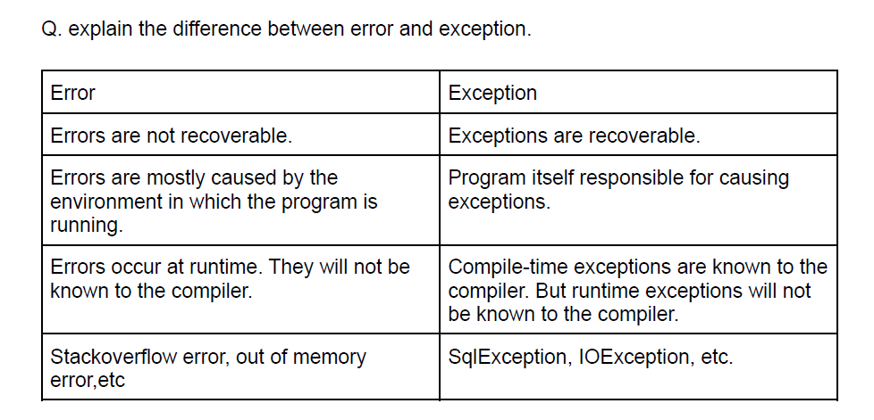

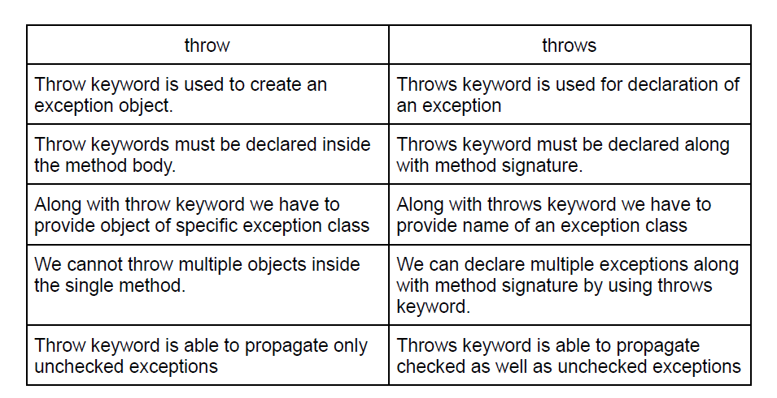

Q. What is the difference in collection, collections, and collection frameworks?
1. Collection is an interface available in the java.util package.
2. Collections is a utility class which contains different methods.
3. Collection framework is a collection of interfaces and classes which can be used
to manipulate data.

Q. What are the drawbacks of arrays?
1. Arrays can be used to store only the same type of data i.e homogeneous data.
2. Array variables are fixed width or static width, meaning array is not resizeable.
3. Since arrays are not resizeable there is a chance of memory wastage.
4. Array manipulation is a time consuming process because the array does not
have an add or remove method.

Q. What is Collection?
1. Collection is a group of multiple objects.
2. In other words an entity which acts as a container for multiple objects, is known
as a collection.
3. It is possible to store the same as well as different types of information inside the
collection object, it means collection classes and interfaces are capable of storing
homogeneous and heterogeneous information.
4. We can efficiently process and store the data by using a collection framework.

ArrayList:
1. ArrayList is an implementation class for list interface.
2. ArrayList class is declared inside the java.util package.
3. ArrayList internally uses the concept of dynamic array to store the elements.
4. Since it is an implementation class of List interface data will be stored in a
sequential manner.
5. ArrayList allows to store null as well as duplicate values.
6. ArrayList implements following marker interfaces:
a. Serializable.
b. Clonnable.
c. RandomAccess.

GIT AND JENKINS QUESTIONS

1] You have worked in Jenkins can you tell me how you have created jobs in Jenkins?

We have separate Dev-Ops Team to create Jenkins jobs at broad level but we also have access to jenkins, so we have created jobs for our internal purpose.
For creating any job we have click on create new job->inside that give name of your job->select free style project->then add.
Beside that we can provide description of our project and in source code management we can choose Git-> provide repo url ->after that provide some schedule if you want to run the job on any specific schedule time.-> select window batch command-file location-save-click on build now for running. After triggering we can check login console.

====================================================================
2] Explain Git workflow.

Step 1:Setup a Github Organization....
Step2:Fork Organization Repository toYour Personal GitHub. ...
Step 3:Clone the Repository toYour Local Machine....
Step 4:Create a Branch for your Working Files....
Step 5:Set Remote RepositorytotheGitHubOrganization. ...
Step 6:GetCoding!
Step7:PulltheMostRecentFiles From the Organization Repo
Step 8:Mergethe Master Branch Into the FeatureBranchStep9:PushYourCodetoyourGitHubRepo
Step10: Make a Pull Request to the Organization Repo
====================================================================
3] Does Jenkins require alocal system for CI?

It is a server-based application and requires a webserver like Apache Tomcat
=====================================================================

4] Howto solveMergeconflictinGIT?
As we are only 2 tester working on this project, if we have any merge conflict I used to pull all the latestfile/scripts to my local system. Then I will analyze the difference between that particular file and mergefile.AfterthatIwillcheckwithmyteammemberwhetherallhisimpthings arecoveredthenIwilladdmystepsandpush thescripttothecentralrepo.
=====================================================================

5] HowtosetupJenkins?

Step1−GototheJenkins dashboardandClick onNewItem

Step2−Inthenextscreen,entertheItem name,inthis casewehavenameditHelloworld.Choosethe‘Freestyleprojectoption’

Step3−Thefollowingscreenwill comeupinwhichyoucanspecify thedetailsofthejob.

Step4 −Weneedtospecifythelocationoffileswhichneedtobebuilt.Inthisexample,wewillassumethatalocalgitrepository(E:\Program)hasbeensetupwhichcontainsa‘HelloWorld.java’file.HencescrolldownandclickontheGitoptionandentertheURLofthelocalgit repository.
Note − If you repository if hosted on Github, you can also enter the url of that repository here. In addition to this, you would need to clickon the Add button for the credentials to add a user name and password to the github repository so that the code can be picked up fromtheremoterepository.

Step5−NowgototheBuildsectionandclick onAddbuildstep →ExecuteWindowsbatchcommand

Step6−Inthecommandwindow,enterthefollowingcommands andthenclick ontheSavebutton.

JavacHelloWorld.javaJava HelloWorld

Step7−Oncesaved,youcanclick ontheBuildNowoptiontoseeifyouhavesuccessfully definedthejob.

Step8−Oncethebuildis scheduled,itwillrun.ThefollowingBuildhistorysectionshows thatabuildis inprogress.

Step 9 − Once the build is completed, a status of the build will show if the build was successful or not. In our case, the following build hasbeenexecuted successfully.Click onthe#1intheBuildhistory tobringupthedetailsofthebuild.

Step10−ClickontheConsoleOutputlinktoseethedetailsofthebuild

=====================================================================

6] Haveyou used GITin yourprojectcan you explainaboutit?
Yes I have used GIT, It is a version control tool. Where we can maintain our central repo. we used tomanageourcodeviaGIT only.WeuseGittomaintain ourprojectinourlocalsystem.So,ifsomeoneliketo work on that project I need to send complete update copy to him and after that he can work on that.There are chances that single project is handled by multiple teams across the globe. So, it will be difficultifwe won’tuse GIT.

Pls also mention GIT command.
Gitstatus-whichshows statusofallthefiles,ifwehavesomefiles whichisnotyetaddedtoourreposoitwillgive usuntracked file.
After that we can use GIT add command after adding it will added to particular index and we can committhisfileusingGitCommit-(Message)wecancommitthisuntrackedfile.AlsowehaveGit Merge,GitPost,GitPull, GitItinetc.

git add [file]
git status
git branch
git merge [branch name]
git push [variable name] master
git pull [Repository Link]
git reset [file]
git commit -m “[ Type in the commit message]”

STRING ONELINEQUE.

java.lang.Stringclassisusedtocreateastringobject.
DifferentStringmethods:

compareTo-TheJavaStringcompareTo()methodisusedforcomparingtwostringslexicographically.
booleanequals()-Thejavastringequals()methodcomparesthetwogivenstringsbased onthecontentofthestring(casesensitive)
Stringconcat() – concattwostrings
booleanequalsIgnoreCase()-Thejavastringequals()methodcomparesthetwogivenstringsbasedonthe contentofthestring(notcasesensitive)
char charAt() – index position - The java string charAt() method returns a char value atthe givenindexnumber.
toUpperCase()–converttouppercase
toLowerCase()–converttolowercase
trim()– remove spacesfromboth sidesofstring
substring()--returnspartofstring
booleanstartWith()–endswith specified suffixornot

====================================================================

javafilemaiekhipublic classhotihai,uskealavaaurclasses vhosaktihaiparpublicekhi.
Ifweneedtocreateonevariableformultiplevalues,weneedtouseArrayconcept.
Int marks[]=newint[5]
Arraycanstoreonlyhomogenousdata,intforintarray,stringforstring,
Ifweneedtoaddheterogeneousdatainarray,weneedtocreateobject array.
Objecta[]=newObject[5];nowwecanadddifferentdatatypeobjects.
Arrayisfixedinsize,whichwedefinewhilecreating.
Ifwetrytoaccessindexvalue>=givenindexvalue,wegotarrayOutOfBundException.
Wecanaddnewelementsinruntimeundercollectionswhileinarraywecannot.
Collectionisagroupofobjects.Torepresentthisweneedcertaininterfacesandclasses.
Common operations we generally do on collections are adding objects, removing objects &findingobject.
Collection(I)iscalledcollectioninterfacehavingmethodswhicharecommonthroughoutallcollections.
Collections is basically a class from java.util package which contains some methods whichwecanuse forcollectionobjects.

List(I)ischildofcollection(I).InlistInsertionorderispreservedandduplicatesareallowed.
ArrayList,LinkedList,Vectorthesearedifferentclasses whichimplementsListInterface.
Set(I) ischildofcollection(I).Insertionorderis notpreserved&duplicatesnotallowed.
HashSet,LinkedHashsetthesearedifferentclasseswhichimplementsSetInterface.
Queue(I)ischildofcollection(I).Weuseditwhenweneedpriortoprocessingmeansfirst infirst out concept.
priorityQueueisclasswhichimplementsSetInterface.
There is one independent interface known as Map(I). In Map(I) objects are created with keyand valuepair.Keycannotbeduplicate, but Valuecanbe.
Hashmap,LinkedHashmap,HashTablethesearedifferentclasseswhichimplementsMapInterface.
WhatevermethodspresentinCollection(I)arealsopresentintheirchildinterfacei.eList,Set,Queue.
add(objecto),addAll(Collectionc),remove(Objecto),removeAll(Collectionc),retainAll(Collectionc)thesearesomemethodsofCollectionInterface.
clear(),isEmpty(),size(),contains(),conatinsAll(),toArray()arealsosomemethods.
InList indexplayanimportantrolebecausewiththehelpofindexonlywecanfindduplicateselements.
add(index,object),get(index),set(index,object)aremethodsofListInterface.
ArrayListal=newArrayList(),itallowsheterogenousobjectsalso.
ArrayList<Str>al=new<str>(),nowitcanstoreobjectsofstringonly.
Collections.Sort(al),Collections.Shuffle(al)Thiswillsort&shuffletheobjectsofarraylist.
Wecanreadthedatawithforloop,foreachloop,iterator()method.
JVM have 2typesofmemoriesStaticpool-staticdata,heaps-Nonstaticdata

OOPSONELINECONCEPTS
Wecancreatemultipleclassesinsideonemainclass.
Classnamecannotbeakeyword.
In Polymorphism, we can create many methods with same name, differentiating with inputparameter. Void Walk(){},void walk(int steps){} . We cannot create duplicate methods or onemethodintoanother.
Compiletimepolymorphism,tellwhichmethodiscalledbeforerunningit.
By applying staticit means now it became class property not object one and it applicable to allobjectsthroughout theclass.
Staticmethodsareaccessedbyclass,NonStaticmethodsareaccessedbyobjects.
Constructor in java is to make objects, we can create constructor but there is one defaultconstructorinjava,likestudentsa=newstudents();highlightedisthedefaultconstructor.
Constructorarenonstaticmethods.Constructorcanbeparameterized
Wecancreateourownconstructorlikestudents b=newstudents(introllNo,Stringname){}
this() keywordisusedtocalloneconstructorbyanother.
this() keywordalsousedinagar2alagalagmethodsmaisameparameternamehai,toconflictna ho isliyethis.name, this.rollNouse krte h. this is known as method overloading bcs you areusing onemethodparameterinsecondone.
Inheritance kamatlabhaikiParentclasskipropertykohumchildclassmaibhiuse karsake.
super()keyword parent class ke constructor ko child mai le atahai , means ab agar hum Sciclasskaobjectbaneyengetostudentsclasskavek objectbanega.

Javakeandarjitnevbydefaultobjectshotehaiunkeekparentsclasshotihaiobject.
Runtimepolymoíphismtellwhichmethodiscalledwhile runningit.
Public,private,protectedinkoaccessmodifierboltehai.
AgarhamnekisimethodkoPrivatebnayahaitovobasusiclassmaihiusehosktahaiaur kahinahi.
Abstraction iskamatlbahaikihumunnecessaryinfokousersehidekretakiuskomainfunctionalityparfocusrahenakinternallogicpr.
abstractkeywordagarkisiclasskesathlagayahaitohumuskaobjectsnahibnasakte.
Aur agarhumkisiclasskoabstractbanatehaitohameusmekuchlogicdene kijarooratnahi hai.Auryeekimppropertyhaiabstractmethodki.
Abstractmethodbannnahaitouskiclasskobhiabstractbannnapadega.
Interfacemethodsarebydefault publicandabstract.
Abstract methodkeandar humconcrete functionsbnasaktehai, parinterfacekeandarkuchnahibnasakte.
Interfaceko usekarnekeliyehumimplementskeywordusekarteh.
Javamaiekclasskemultipleparentnahihosaktebcsjavamultipleinheritancesupportnikrta.Iskeliyehuminterface kausekartehai.
Literalsmeansarethestringvalues,integervalues,comments,keyword.

INTERVIEW QUESTIONS

1] Explain Data Types?
2] What is Static and Non Static method ?
3] Explain variables ?
4] What is String class?
5] Difference between String. String Builder, String Buffer ?
6] Explain coupling ?
7] Constructor ?
8] What is Casting and its types?
9] What is This and Supper Keyword?
10] What is Abstract ?
11] What is Inheritance and why it is used in Java?
12] Different between Inheritance and Encapsulation?
13] Different between method Over Riding and Method Overloading?
14] Can we achieve multiple Inheritance in java .How you can achieved multiple inheritance in java ?
No….
15] Can we declare Abstract class as static?
16] Give real life example of Polymorphism? Explain
17] Diff between Interface and Abstract ?
18] What is interface ?
19] Explain All access Specifier ?
20] Can we declare constructor as private?
21] What is difference between Final. Finalize and Finally in java?
22] Can we create object of Interface?

